RESOLUTION NO.__________

RE: CERTIFICATE OF APPROPRIATENESS UNDER THE
PROVISIONS OF THE ACT OF THE PENNSYLVANIA
LEGISLATURE 1961, JUNE 13, P.L. 282 (53
SECTION 8004) AND BETHLEHEM ORDINANCE NO.
3952 AS AMENDED.

The applicant proposes to remove the existing garage doors and install new brick piers and spandrels with new wood garage doors at 55 W. Market St.

NOW, THEREFORE, BE IT RESOLVED by the Council of the City of Bethlehem that a Certificate of Appropriateness is hereby granted for the proposal.

Sponsored by: (s)

(s)

ADOPTED BY COUNCIL THIS DAY OF

(s)
President of Council

ATTEST:

(s)
City Clerk

HISTORICAL & ARCHITECTURAL REVIEW BOARD

The applicant proposes to remove the existing garage doors and install new brick piers and spandrels with new wood garage doors at 55 W. Market St.

APPLICATION #4:

Donald Kaas
55 W. Market St.
Bethlehem, PA 18018

OWNER:

__________________________________________________________________________

The Board upon motion by Beth Starbuck and seconded by Marsha Fritz adopted the proposal that City Council issue a Certificate of Appropriateness for the following:

- The brick piers are to match the house.

2. Doors will be stained solid black.

3. Also installing a black powder coated gate.

4. The motion was unanimously approved.

__________________________________________________________________________

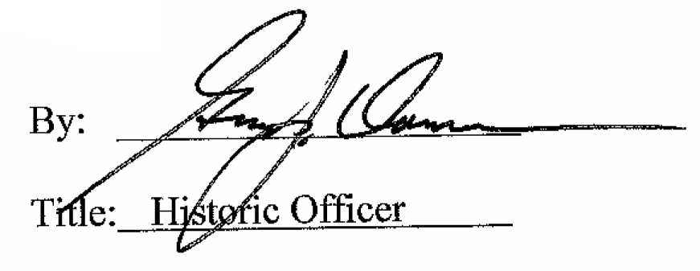

Date of Meeting: July 11, 2018

